DATA LEAKAGE:
Data leakage happens when your training data contains information about the target, but similar data will not be available when the model is used for prediction. This leads to high performance on the training set (and possibly even the validation data), but the model will perform poorly in production.
In other words, leakage causes a model to look accurate until you start making decisions with the model, and then the model becomes very inaccurate.

​​Common Data Leakage Patterns:
1. Target Leakage:
Features include information that is directly or indirectly derived from the target.

Example:
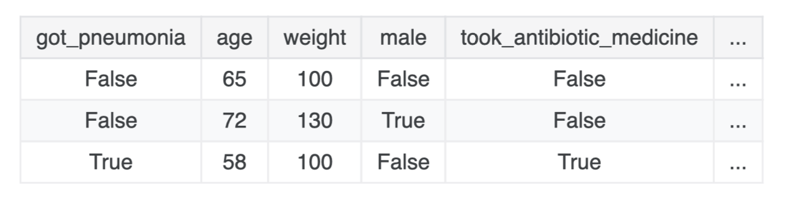
That’s basically giving the answer to the model.
If a feature is created after the outcome happens, it’s leakage.

2. Train-Test Contamination:
You accidentally leak info from test set into training.

Typical mistakes:
- Scaling before splitting
- Feature selection on full dataset
- Imputation using full dataset

Eg:
scaler.fit(X) X_train, X_test = train_test_split(X)
X_train, X_test = train_test_split(X) scaler.fit(X_train)

3. Time Leakage:
Future data is used to predict the past.

Example:
Predict stock price at time T using:
- price at time T+1

4. Data Duplication Leakage
Same or very similar records appear in both train and test.

Name | Age | Salary | Bought
John | 25 | 50000 | Yes
Sarah | 30 | 60000 | No
Mike | 28 | 55000 | Yes
John | 25 | 50000 | Yes

Result:
- Model memorizes instead of learning

5. Aggregation Leakage
Using global statistics that include future/test data.

Product | Bought (target encoding)
A | 1
A | 0
A | 1
B | 0
B | 0

Example:
- Mean encoding using full dataset
- Rolling averages that include future values

6. Feature Engineering Leakage
Features accidentally encode the target.

User | Date | Purchased
A | Jan 1 | 0
A | Jan 5 | 1
A | Jan 10 | ? (predict)

Example:
- days_since_last_purchase computed using future info
- Label encoding fitted on full dataset

Prevention Techniques

1. Train-Test split:
X_train, X_test, y_train, y_test = train_test_split(...)
Then do:
- scaling
- encoding
- imputation
ONLY on training data.

2. Using Pipelines:

This prevents accidental leakage during cross-validation.

Eg:
from sklearn.pipeline import Pipeline
from sklearn.preprocessing import StandardScaler
from sklearn.ensemble import RandomForestClassifier
pipeline = Pipeline([
('scaler', StandardScaler()),
('model', RandomForestClassifier())
])

3. Using Time Order (for time series)
Use:
- TimeSeriesSplit
- No shuffling
Shuffling data = cheating.

4. Validation:
Use:
- Cross-validation
- Separate validation set
If accuracy drops heavily in real-world test → leakage was there.

5. Handle Time-Series Carefully
Create lag features:
df['lag_1'] = df['Close'].shift(1)
- Drop NaNs

